

**ADVANCED JAVA**

**PROJECT REPORT**

**Quarter II (Year 2)**

***Submitted by***

|  |  |
| --- | --- |
| **Anne Asrita** | **E0121057** |
| **Ruthvika Muchala** | **E0121036** |
| **Sivane Senthil** | **E0121027** |
|  |  |
|  |  |

***In partial fulfilment for the award of the degree of***

**BACHELOR OF TECHNOLOGY**

**in**

**COMPUTER SCIENCE AND ENGINEERING**

**(Artificial Intelligence and Machine Learning)**

**Sri Ramachandra Engineering and Technology**

**Sri Ramachandra Institute of Higher Education and Research, Porur, Chennai -600116**

**JANUARY, 2023**

**Table of Contents**

**Title**

1. Objective
2. Abstract
3. Modules Used
4. Implementation
5. Output

5. Future work 6.References

**Objective:**To create a web application that has the necessary details regarding tourism using advanced java concepts

**Abstract**:The abstract of this project is creating a web application by using

advanced Java modules for tourism management system. In this application the

user can select the state that the user wants to visit, and it would retrieve the

tourist attractions of that particular state with some other necessary details for

their ease of travel.

**Modules used:**

* Reading HTML form data with JSP(GET,POST,PUT,DELETE)
* JDBC SQL syntax and environment
* CRUD in JSP(Create,Update,Read and Delete)
* Page redirect
* Creating sample web application-JSP

**Implementation:**

**.project**

<?xml version="1.0" encoding="UTF-8"?>

<projectDescription>

<name>pro</name>

<comment></comment>

<projects>

</projects>

<buildSpec>

<buildCommand>

<name>org.eclipse.jdt.core.javabuilder</name>

<arguments>

</arguments>

</buildCommand>

<buildCommand>

<name>org.eclipse.wst.common.project.facet.core.builder</name>

<arguments>

</arguments>

</buildCommand>

<buildCommand>

<name>org.eclipse.wst.validation.validationbuilder</name>

<arguments>

</arguments>

</buildCommand>

</buildSpec>

<natures>

<nature>org.eclipse.jem.workbench.JavaEMFNature</nature>

<nature>org.eclipse.wst.common.modulecore.ModuleCoreNature</nature>

<nature>org.eclipse.wst.common.project.facet.core.nature</nature>

<nature>org.eclipse.jdt.core.javanature</nature>

<nature>org.eclipse.wst.jsdt.core.jsNature</nature>

</natures>

</projectDescription>

**classpath:**

<?xml version="1.0" encoding="UTF-8"?>

<classpath>

<classpathentry kind="src" path="src"/>

<classpathentry kind="con" path="org.eclipse.jdt.launching.JRE_CONTAINER/org.eclipse.jdt.internal.debug.ui.launcher.StandardVMType/jre1.8.0_311">

<attributes>

<attribute name="owner.project.facets" value="java"/>

</attributes>

</classpathentry>

<classpathentry kind="con" path="org.eclipse.jst.server.core.container/org.eclipse.jst.server.tomcat.runtimeTarget/Apache Tomcat v9.0">

<attributes>

<attribute name="owner.project.facets" value="jst.web"/>

</attributes>

</classpathentry>

<classpathentry kind="con" path="org.eclipse.jst.j2ee.internal.web.container"/>

<classpathentry kind="con" path="org.eclipse.jst.j2ee.internal.module.container"/>

<classpathentry kind="output" path="build/classes"/>

</classpath>

**src:**

import java.io.IOException;

import javax.servlet.ServletException;

import javax.servlet.annotation.WebServlet;

import javax.servlet.http.HttpServlet;

import javax.servlet.http.HttpServletRequest;

import javax.servlet.http.HttpServletResponse;

import java.sql.Connection;

import java.sql.DriverManager;

import java.sql.ResultSet;

import java.sql.Statement;

import javax.servlet.RequestDispatcher;

import java.io.PrintWriter;

/**

* Servlet implementation class Db

*/

@WebServlet("/Db")

public class Db extends HttpServlet {

private static final long serialVersionUID = 1L;

/**

* @see HttpServlet#HttpServlet()

*/

public Db() {

super();

// TODO Auto-generated constructor stub

}

/**

* @see HttpServlet#doGet(HttpServletRequest request, HttpServletResponse response)

*/

protected void doGet(HttpServletRequest request, HttpServletResponse response) throws ServletException, IOException {

try{

// RequestDispatcher bhanu = request.getRequestDispatcher("ola.html");

// bhanu.include(request, response);

PrintWriter neer = response.getWriter();

String nam = request.getParameter("selection");

System.out.println(nam);

Class.forName("com.mysql.jdbc.Driver");

Connection con = DriverManager.getConnection("jdbc:mysql://localhost/tourism","root","");

Statement stat = con.createStatement();

System.out.println("connected");

ResultSet rs = stat.executeQuery("select * from tour where State ="+"'"+nam+"'");

while (rs.next())

{ String nm = rs.getString("Places");

System.out.println(nm);

neer.print("<body style='background-color:lightblue;'><div style='margin-left:30px;margin-top:50px;'><h1 style='background-color:lightpink;padding:30px;width:320px;align:center;font-family: 'Brush Script MT', cursive;' >Tourist Attractions in the State are :</h1><div style='margin-top:10%;margin-left:60px;margin-right:60px;background-color:black;padding:60px;'><h2 style='color:blue;' align='center'>"+nm+"</h2></div></body>");

}

}

catch(Exception e){

}

}

}

**ola**

.footer-basic {

padding:40px 0;

background-color:#ffffff;

color:#4b4c4d;

}

.footer-basic ul {

padding:0;

list-style:none;

text-align:center;

font-size:18px;

line-height:1.6;

margin-bottom:0;

}

.footer-basic li {

padding:0 10px;

}

.footer-basic ul a {

color:inherit;

text-decoration:none;

opacity:0.8;

}

.footer-basic ul a:hover {

opacity:1;

}

.footer-basic .social {

text-align:center;

padding-bottom:25px;

}

.footer-basic .social > a {

font-size:24px;

width:40px;

height:40px;

line-height:40px;

display:inline-block;

text-align:center;

border-radius:50%;

border:1px solid #ccc;

margin:0 8px;

color:inherit;

opacity:0.75;

}

.footer-basic .social > a:hover {

opacity:0.9;

}

.footer-basic .copyright {

margin-top:15px;

text-align:center;

font-size:13px;

color:#aaa;

margin-bottom:0;

}

*/

.bg-cover {

background-size: cover !important;

}

body {

min-height: 60vh;

}

*, *:before, *:after {

box-sizing: border-box;

-webkit-font-smoothing: antialiased;

-moz-osx-font-smoothing: grayscale;

}

body {

background: linear-gradient(to right, #ea1d6f 0%, #eb466b 100%);

font-size: 12px;

}

body, button, input {

font-family: 'Montserrat', sans-serif;

font-weight: 700;

letter-spacing: 1.4px;

}

.background {

display: flex;

min-height: 100vh;

}

.container {

flex: 0 1 700px;

margin: auto;

padding: 10px;

}

.screen {

position: relative;

background: #3e3e3e;

border-radius: 15px;

}

.screen:after {

content: '';

display: block;

position: absolute;

top: 0;

left: 20px;

right: 20px;

bottom: 0;

border-radius: 15px;

box-shadow: 0 20px 40px rgba(0, 0, 0, .4);

z-index: -1;

}

.screen-header {

display: flex;

align-items: center;

padding: 10px 20px;

background: #4d4d4f;

border-top-left-radius: 15px;

border-top-right-radius: 15px;

}

.screen-header-left {

margin-right: auto;

}

.screen-header-button {

display: inline-block;

width: 8px;

height: 8px;

margin-right: 3px;

border-radius: 8px;

background: white;

}

.screen-header-button.close {

background: #ed1c6f;

}

.screen-header-button.maximize {

background: #e8e925;

}

.screen-header-button.minimize {

background: #74c54f;

}

.screen-header-right {

display: flex;

}

.screen-header-ellipsis {

width: 3px;

height: 3px;

margin-left: 2px;

border-radius: 8px;

background: #999;

}

.screen-body {

display: flex;

}

.screen-body-item {

flex: 1;

padding: 50px;

}

.screen-body-item.left {

display: flex;

flex-direction: column;

}

.app-title {

display: flex;

flex-direction: column;

position: relative;

color: #ea1d6f;

font-size: 26px;

}

.app-title:after {

content: '';

display: block;

position: absolute;

left: 0;

bottom: -10px;

width: 25px;

height: 4px;

background: #ea1d6f;

}

.app-contact {

margin-top: auto;

font-size: 8px;

color: #888;

}

.app-form-group {

margin-bottom: 15px;

}

.app-form-group.message {

margin-top: 40px;

}

.app-form-group.buttons {

margin-bottom: 0;

text-align: right;

}

.app-form-control {

width: 100%;

padding: 10px 0;

background: none;

border: none;

border-bottom: 1px solid #666;

color: #ddd;

font-size: 14px;

text-transform: uppercase;

outline: none;

transition: border-color .2s;

}

.app-form-control::placeholder {

color: #666;

}

.app-form-control:focus {

border-bottom-color: #ddd;

}

.app-form-button {

background: none;

border: none;

color: #ea1d6f;

font-size: 14px;

cursor: pointer;

outline: none;

}

.app-form-button:hover {

color: #b9134f;

}

.credits {

display: flex;

justify-content: center;

align-items: center;

margin-top: 20px;

color: #ffa4bd;

font-family: 'Roboto Condensed', sans-serif;

font-size: 16px;

font-weight: normal;

}

.credits-link {

display: flex;

align-items: center;

color: #fff;

font-weight: bold;

text-decoration: none;

}

.dribbble {

width: 20px;

height: 20px;

margin: 0 5px;

}

@media screen and (max-width: 520px) {

.screen-body {

flex-direction: column;

}

.screen-body-item.left {

margin-bottom: 30px;

}

.app-title {

flex-direction: row;

}

.app-title span {

margin-right: 12px;

}

.app-title:after {

display: none;

}

}

@media screen and (max-width: 600px) {

.screen-body {

padding: 40px;

}

.screen-body-item {

padding: 0;

}

}

**Output:**

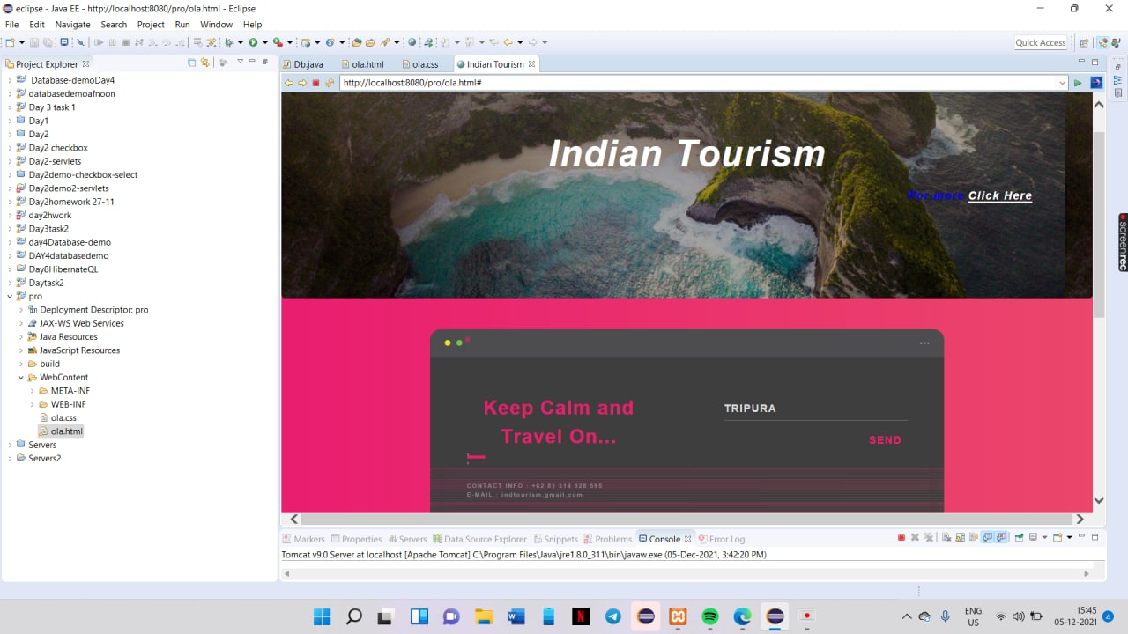

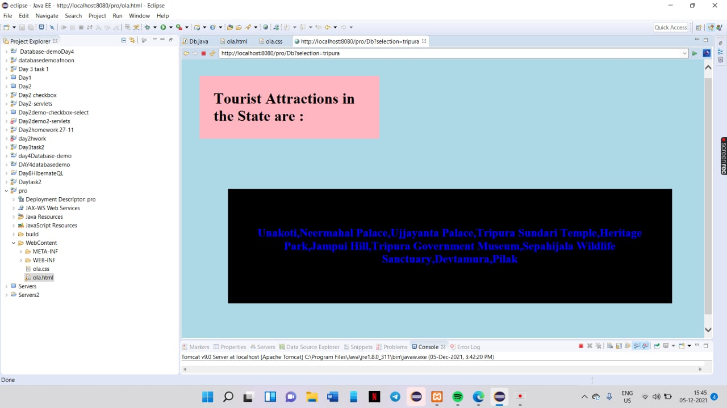

**Future work:**

To add more features in the java application like seasonal tourist spots in

the particular state and improve html page.

**References:**

<https://www.w3schools.com/>

<https://www.javatpoint.com/>

<http://youtube.com/>